

UIPath Automation

Process design document

**Process Design Document History**

| Date | Version | Role | Name | Organization | Function | Comments |
| --- | --- | --- | --- | --- | --- | --- |
|  |  | Author |  |  |  |  |
|  |  | Reviewer |  |  |  |  |

Table of Contents

1. Introduction……………………………………………………………………………………………...4
   1. Purpose of the document………………………………………………………………………….4
   2. Objectives…………………………………………………………………………………………...4
   3. Process key contacts………………………………………………………………………………4
   4. Additional source(s) of process documentation…………………………………………………4
2. AS IS Process Description 4
   1. Process overview 5
   2. High Level process diagram 7
   3. Detailed Process map 8
   4. Detailed Process Steps 11

2.5. Exceptions handling 14

* 1. Error mapping and handling …………………………………15
  2. In-Scope application details …………………………………17
     1. Detailed application field mapping …………………………………17

2.7.2 XML TO PDF Mapping – Part #1 Header …………………………………………………17

1. Development details …………………………………17
   1. Prerequisites for development …………………………………17
   2. Password policies …………………………………17
   3. Credentials and asset management …………………………………17
   4. Operating Environment………………………………………………………………………… 17
2. Testing preliminary details …………………………………**18**
   1. Alpha testing …………………………………18
   2. User Acceptance Test …………………………………18
3. Annexure …………………………………19
   1. UIPATH automated process details ………………………………. 19

# 1. Introduction

## 1.1 Purpose of the Document

## The Process Design Document describes the business processes chosen for automation using UIPath Robotic Process Automation (RPA) technology.

## The document describes the sequence of steps performed as part of the process, the conditions and rules of the process prior to automation. This design document serves as a base documentation for developers to collect the details required for robotic automation of the same business process.

## 1.2 Objective

## The objective of this process automation is intricately linked to the overarching project business case, aligning with the following key objectives:

## 1. Automate the process of accessing the NSE India website securely and reliably to fetch stock data for NIFTY 50 index stocks.

## 2. Identify the top 5 gainers and losers from the NIFTY 50 index based on calculated metrics.

## 3. Extract relevant stock data accurately and efficiently, including Prev. Close, Open, High, Low, Close, VWAP, and Adjusted Price*.

## 4. Calculate price change, percentage change, and high-low range for each stock based on the extracted data.

## 5. Format the extracted stock data and calculated metrics into a detailed report suitable for analysis and decision-making purposes.

## 6. Implement error-handling mechanisms to address exceptions and ensure the robustness of the automation process.

Key Deliverable:

* Bot Functionality (Extract Relevant information)
* Report Generation
* Accurate and Reliable

## 1.3 Process Key Contacts

## The design document includes concise but complete requirements of process and it is built based on the inputs provided

## by the process Subject Matter Expert (SME).

## For escalation points, please review the table below:

| Role | Name | Date of Action | Notes |
| --- | --- | --- | --- |
| Process SME |  |  |  |
| Reviewer/ Owner |  |  |  |
| Approval for production |  |  |  |

# 2. AS IS Process Description

## 2.1 Process Overview

General information about the process selected for RPA, prior to automation:

|  | AS IS process details |
| --- | --- |
| Process full name | NSE Stock Details Bot |
| Function | Extract stock details |
| Department | Business and Project management |
| Process short description  (operation, activity, outcome) | Automating the extraction of top 5 stock gainers/losers from the NSE India website to enhance data-driven decision-making and streamline financial analysis processes. |
| Role required for performing the process |  |
| Process schedule | Daily, Monday to Friday, 6:00 PM IST |
| # of items processes /month | ~300 |
| Average handling time per item | 2 min |
| Peak period (s) |  |
| # of FTEs supporting this activity |  |
| Level of exception rate |  |
| Input data | Top 5 stock gainers/losers |
| Output data | Detailed report of price change, percentage change, high-low range etc. |

## 2.2 High Level Process Diagram

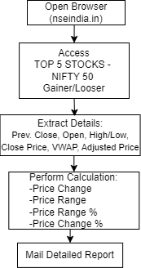

## 2.3 Detailed Process Map

This chapter presents the chosen process in detail, which enables the developer to build the automated process.

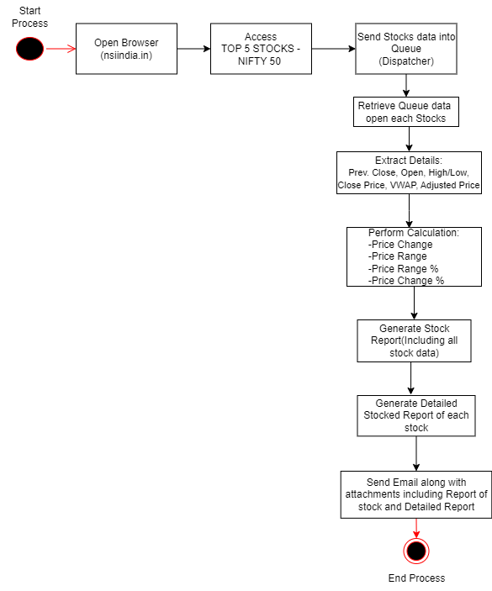

| Step | Short Description |
| --- | --- |
| 1.1 | Open the NSE India Website |
| 1.2 | Access the TOP 5 Stocks - NIFTY 50, |
| 1.3 | For each activity on TOP 5 Stocks - NIFTY 50, Gainer/Looser perform the following steps |
| 1.4 | Get Text: Prev. Close, Open, High, Low, Close, VWAP, and Adjusted Price* |
| 1.5 | Perform Calculation: |
| 1.5.1 | Price Change:  This is the difference between the previous close and the last traded price (LTP).  Price Change = LTP - Previous Close |
| 1.5.2 | Price Range:  The difference between the high and low prices of the day.  Price Range = High - Low |
| 1.5.3 | Price Range Percentage:  This indicates how much the price has ranged in percentage terms.  Price Range Percentage = {{High - Low}/Previous-Close}*100% |
| 1.5.4 | Price Change Percentage:  Indicates the percentage change in price from the previous close to the current last traded price.  Price Change Percentage = {{LTP - Previous Close}\Previous-Close} * 100% |
| 1.6 | Repeat above process for each stocks |
| 1.7 | Store Stock reports |
| 1.8 | Generate Detailed Stocked Report of each stock |
| 1.8.1 | Store: Price Change, Price Range, Price Range Percentage |
| 1.9 | Send Email along with attachments including Report of stock and Detailed Report |

## 2.4 Detailed Process Steps

| Step | Step action description | Screenshot | Expected result | Remarks |
| --- | --- | --- | --- | --- |
| 1.1 | Open the NSE India website |  | Opening of a screen  : Website not loaded | Possible exception:  - Handle exception if  Website not available |
| 1.2 | Extract top 5 Gainers/Losers Stocks |  | List of Stocks | Possible exception:  *-* Handle exception if  Ui element not found |
| 1.3 | For each stock perform the following steps |  |  |  |
| 1.3A | Search for stock in the search bar |  |  |  |
| 1.3B | Extract the relevant information like Last Traded Price, Previous close, close, open, High, Low, Adjusted Price, VWAP. |  | Stock details are visible | NA |
| 1.3C | Generate a Report of the stocks that has all the information which are previously extracted. |  | Stores in the data table | NA |
| 1.3D | Calculate Price Change, by Using the formula Price Change = Last Traded Price - Previous Close |  | NA | NA |
| 1.3E | Calculate Price Range, by using the formula Price Range = High – Low. |  | NA | NA |
| 1.3F | Calculate **Price Range Percentage**, by using the formula  Price Range Percentage = ((High – Low )/Previous Close) * 100 |  | NA | NA |
| 1.3G | Calculate **Price Change Percentage**, by using the formula  Price Change Percentage = ((Last Traded Price – Previous Close) / Previous Close) * 100 |  | NA | NA |
| 1.3H | Generate a detailed report of each stock containing details like price change, price change percentage, price range, price range percentage. |  | Stores data into Excel file | NA |
| 1.4 | Send Email including Report Generated in |  |  | Possible Exceptions   * Handle exceptions if email or password is incorrect |

## 2.5 Exception Handling

Exceptions identified in the automation process can be classified as:

| Area | Known | Unknown |
| --- | --- | --- |
| Business | Previously encountered. A scenario is defined with clear actions and workarounds  for each case. | New situation never encountered before – it should not really happen. It can be caused by external factors. |

Based of the above criteria the table below should reflect all exceptions identifiable in the process and map the expected action the robot needs to take for each exception.

Below are the exceptions captured during the process study. These are known exceptions, met in practice before. For each exception an action is defined.

Insert as many rows as required in the table, to capture all exceptions in a comprehensive list.

| E# | Exception Name | Step where exception is encountered | Parameters | Action to be taken |
| --- | --- | --- | --- | --- |
| 1 | Website not available | Step # **1.1** | If Web app is not available | Wait for 10 min and retry  Send email to mrakhil42@gmail.com  “Hello,  NSE India Website could not be open because the website is not available’’ |
| 2 | Incorrect email or password | Step # **1.4** | If message for incorrect username or password  exist | Send email to mrakhil42@gmail.com  “Hello,  The username or the email is incorrect. Please check and restart Thank you’’ |
| 3 | No UI element found | Step # **1.2** | If UI Element is not found | Wait 10 min and retry and send email to mrakhil42@gmail.com  “Hello,  The UI Element not found. Please check and restart  Thank you’’ |

For all the other unanticipated or unknown exceptions, the robot should send an email notification at mrakhil42@gmail.com with the original email and error message screenshot attached

## 2.6 Error Mapping and Handling

A comprehensive list of all the errors or warnings or notification should be consolidated here with the description and action to be taken, for each, by the Robot.

Errors identified in the automation process can be classified as:

| Area | Known | Unknown |
| --- | --- | --- |
| Technology | Experienced previously, action plan or workaround available for it. | New situation never encountered before, or may happened independent of the applications used in the  Process. |

Based on the above criteria the table below should reflect all errors identifiable in the process and map the expected action the robot needs to take for each error.

Insert as many rows as required in the table, to capture all errors in a comprehensive list.

| E# | Error Name | Step where error is encountered | Parameters | Action to be taken |
| --- | --- | --- | --- | --- |
|  | Application Crash / Internal Server Error | Any step | Error message | Refresh / Retry  Send email with screenshot to [mrakhil42@gmail.com](mailto:mrakhil42@gmail.com)  Close application and run the sequence again |
|  | Application unresponsive / page not loading | Any step | No response / blank page | Wait 5 minutes and retry 2 times.  Close application and run the sequence again |

## 2.7 In-Scope Application Details

The table below lists all the applications that are used as part of the process automated, at various steps in the flow.

| # | Application Name and Version | System Lang | Login Module | Interface | Environment/ Access Method | Comments |
| --- | --- | --- | --- | --- | --- | --- |
| 1 | NSE India | EN | n/a | Web | Web  Browser |  |
| 2 | Microsoft Excel | EN | n/a | Client | Local  desktop |  |

# 3. Development Details

## 3.1 Prerequisites for Development

* Development or testing environment will be provided for development.
* Development/testing environment is an exact replica of production environment.
* Dedicated system and application access are given to developers with adequate permission.

## 3.2 Password Policies

Users manage their own passwords. There are no special policies in place

## 3.3 Credentials and assets management

Log on details (user IDs and passwords) should be stored under “Windows Credential Manager” or “UIPath Orchestrator Assets”

# 4. Testing Preliminary Details

Below are the various stages in testing. Update each item with Testing plan.

| Testing | Owner | Start Date | End Date | #of test cases | % of Success | Status |
| --- | --- | --- | --- | --- | --- | --- |
| Alpha | RPA Project Lead |  |  |  |  |  |
| User Acceptance Testing | Process SME |  |  |  |  |  |
| Regression Testing | Process Owner |  |  |  |  |  |
| Security Testing | Client IT / Info Sec Team |  |  |  |  |  |

## 4.1 Alpha Testing

Alpha and Beta Testing: Alpha testing is the testing done by RPA developers and RPA project lead after development.

## 4.2 User Acceptance Test

Business operations team creates test cases and provides test data for development and testing. This is due to be provided by POC.

# 5. Annexure

## 5.1 UIPATH automated process details

| Note: this step is to filled in after automation process is complete |
| --- |

**Automation overview**: (time to dev, test, etc)

**Robots type**: Back Office Robot

**Level of human intervention required**:

**Use of Orchestrator**:

**Exceptions recorded in automation process:**

**Errors identified in the automation process**:

**Challenges identified in the automation process**:

**Lessons Learned**:

**Any adjustments** done in the automation process to facilitate (steps tweaked from the human way of working to an automatic programing way of working).All activities which have been performed to tweak the as is process to enable higher rates of automation on the process.

* Process Assumption
* Input data assumption
* Number or types of input to be received
* Skip logon interface and collect back end details
* Extract data from backend without opening the file…
* Data conversion / formatting

**Reporting:** The details and format of the logging available in the workflow must be specified here. (Whether it is creating local log reports or Orchestrator logs).

The format should be specified by the business users.

**Workflow and scripts:** A brief of each workflow and the sequence in which are executed should be described here.